**Name:** Richard Manuel Vivanco Granda

Age: 23

Address: Bellavista Mz 20 Villa 17

City: Guayaquil

Telephone: 0991111073

Email: rvivanco@espol.edu.ec

**Host Company :** Olympus

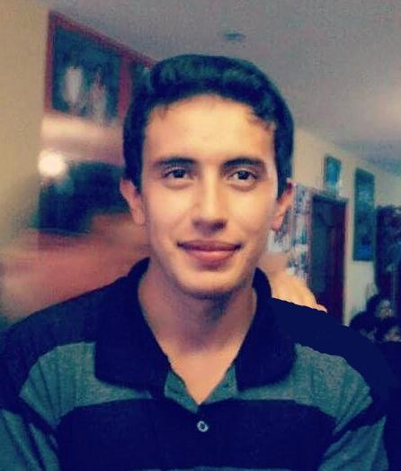

I chose to live this experience of working outside the country because reasons like improve my English, meet new people and new culture will help me in the future personally and professionally both, more than these I will be able to show my skills and knowledge to others and thus be willing to help in the tasks were assigned to me with the kindness and respect that characterize me.

**University :**Escuela Superior Politécnica del Litoral

**Career :** Telematic Engineering

**Semester :** 8th Semester

***Spoken Languages:* Spanish:** Native

**English:** Intermediate

***Basic Utilitaries:*** Word, Excel, Power Point, Internet.

* **Name of the Company :** MEGADATOS S.A (NETLIFE)
  + **Ocupation:** Helpdesk Intern
  + **Tasks: -** Fix Computers

**-** Set up networking devices

* **Name :** Ángel Estuardo Valle Vera

Telephone : 092844935

E-mail : angelvalle131@gmail.com

* **Name :** Teresa María Vivanco Arias

Telephone : 097189023

E-mail : [terevivanco2005@latinmail.com](mailto:terevivanco2005@latinmail.com)

* **Name of Seminar or Course :** Driver Professional License Type C

**Place of Seminar :** Conduespol, Guayaquil

* **Name of Seminar or Course :** Internet of Everything

**Place of Seminar :** Cisco Networking Academy

* **3 Hobbies or personal interest**

**ACADEMIC INFORMATION**

**WORK EXPERIENCE**

**REFERENCES**

**ADDITIONAL PREPARATION: SEMINARS, COURSES**

* **Name of Seminar or Course :** Introduction to Cybersecurity

**Place of Seminar :** Cisco Networking Academy

* **Name of Seminar or Course :** Entrepreneurship

**Place of Seminar :** Cisco Networking Academy

**HOBBIES AND PERSONAL INTEREST**

**Hobbies :**

I like :

Playing Basketball, Chess, Puzzles.

**Interests :**

I'm really interested in :

Improving my skills about a new language like English.

Fixing computers and set up networking devices on a big scale.

Learning about new cultures and places around the world.